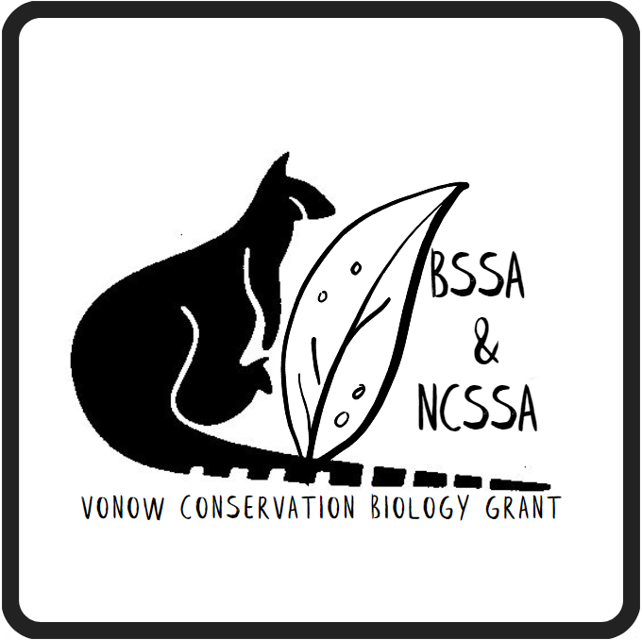

Vonow Conservation Biology Grant 2024

This grant is jointly sponsored by the Biology Society of South Australia (BSSA) and the Nature Conservation Society of South Australia (NCSSA). The grant aims to assist Honours and postgraduate student research into aspects of conservation biology in South Australia.

Funds up to the value of $3,300 per successful applicant are available for research aimed at:
- improving understanding of the conservation status of species or ecological communities;
- providing recommendations for improvement of some aspect of biodiversity conservation;
- understanding the ecology of species or communities;
- and understanding threats to biodiversity and management of those threats.

The closing date for applications for the 2024 Vonow Conservation Biology Grant is Sunday 5th of May 2024.

GENERAL REQUIREMENTS

Read carefully before submitting your application:

- Funding is available to support travel for the purposes of field-work or research, equipment purchase or hire, purchase of materials or promotion of research results. Preference will be given to projects that have a field research component. Overheads, salaries, bursaries and conference travel will not be funded.
- Applicants can apply for up to $3,300. However, applications for smaller amounts will be regarded favourably. We reserve the right to partially fund a project.
- Applicants should apply for funds for projects or part-projects with a maximum of 12 months duration.
- Applicants are asked to lodge their signed application in a PDF format via an email by the due date.
- Applications should be submitted using only the form provided. Supporting material will be requested if necessary.
- Funding is only available to research students undertaking studies at Honours Degree, Graduate Diploma, Masters Degree or PhD level at accredited Universities. Funding for Undergraduate projects will only be available in exceptional circumstances.
- Applicants must be financial members of BSSA. Membership dues ($10 p.a.) will be accepted with grant applications, or paid separately to BSSA (see website for membership details – www.biologysocietysa.com). Applicants who apply but are not members by the due date will not have their applications accepted. Membership of NCSSA will be provided for free the first year ($40), and you will have the opportunity to continue in a paid capacity in future years.
- All research must abide by the National Parks and Wildlife Act 1972, the Native Vegetation Act 1991, the Environment Protection and Biodiversity Conservation Act 1999 and any other relevant Acts or Regulations.
- Researchers must obtain all necessary permits and approvals for conducting their research.
- Successful applicants are required to:
  - make a 10-15 minute presentation of their research at the mid 2025 BSSA & NCSSA Grant Recipient Meeting.
  - submit a non-technical article (1-page) on their research for publication in the BSSA membership newsletter and the NCSSA newsletter within 12 months of receipt of the grant.
- The NCSSA or its delegates will administer the Vonow Conservation Biology Grants. Successful applicants are required to remain in contact with the BSSA and NCSSA until the conditions of the grant are fulfilled.
- All recipients of the Vonow Conservation Biology Grants must enter into an agreement outlining the conditions of the grant.
- A copy of the final report and/or the agreed end product of the research must be forwarded to the BSSA and NCSSA via an email, upon completion of the project.

Applications on the appropriate form should be directed to:

Administrative Manager
Vonow Conservation Biology Grant
Nature Conservation Society of South Australia
5 Milner Street
HINDMARSH SA 5007

Email: NCSSA@ncssa.asn.au and cc the BSSA email: biolsocsa@gmail.com
Phone: (08) 7127 4630
The closing date for applications for the 2024 Vonow Conservation Biology Grant is Sunday 5th of May 2024.

Application Form

- Applicant and institution information

  - APPLICANT(S) DETAILS
Name: …………………………………………………………………………………………………………………………
Level of award for which research is being undertaken: ……………………………………………………
Current Level of Qualification: …………………………………………………………………………………………
Year of enrolment: …………………………………………………………………………………………………………

Telephone contacts: H ………………………………………… M ………………………………………………
Email: …………………………………………………………………………………………………………………………

  - SUPERVISOR(S) DETAILS
Supervisor 1: ………………………………………………………………………………………………………………
Institution/Department: ………………………………………………………………………………………………
Email: …………………………………………………………………………………………………………………………

Supervisor 2 (if applicable}: …………………………………………………………………………………………
Institution/Department: ………………………………………………………………………………………………
Email: …………………………………………………………………………………………………………………………

  - INSTITUTION PAYEE DETAILS

Name of institution payee: ……………………………………………………………………………………………
Contact person: ……………………………………………………………………………………………………………
Position: ………………………………………………………………………………………………………………………
Department: …………………………………………………………………………………………………………………
Telephone: ……………………………………………………
Institution’s ABN …………………………………………………… GST Registered: Yes/No

  - Previous experience of the applicant(s) undertaking research or conservation projects

Previously completed research or biodiversity conservation projects should be included (50 words)
………………………………………………………………………………………………………………………………………………………………………………………………………………………………………………………………………………………………………………

- Project information
  - PROJECT TITLE
…………………………………………………………………………………………………………………………………………………
…………………………………………………………………………………………………………………………………………………

  - PROJECT LOCATION (provide a map reference if necessary)
…………………………………………………………………………………………………………………………………………………
…………………………………………………………………………………………………………………………………………………

  - PROJECT DURATION
Date of commencement: ……………………… Date of completion: …………………………
  - PROJECT DESCRIPTION

2.4.1. Project Summary (100 words)
…………………………………………………………………………………………………………………………………………………
…………………………………………………………………………………………………………………………………………………
…………………………………………………………………………………………………………………………………………………

2.4.2 Aims and Objectives (100 words)
…………………………………………………………………………………………………………………………………………………
…………………………………………………………………………………………………………………………………………………
…………………………………………………………………………………………………………………………………………………

2.4.3 Methodology and/or relevance to other research projects currently being undertaken (100 words)
…………………………………………………………………………………………………………………………………………………
…………………………………………………………………………………………………………………………………………………
…………………………………………………………………………………………………………………………………………………
2.4.4 Please outline how this money would help answer a specific question(s) in your project (100 words)
…………………………………………………………………………………………………………………………………………………
…………………………………………………………………………………………………………………………………………………
…………………………………………………………………………………………………………………………………………………
2.4.5 Benefits of the project to biodiversity conservation in South Australia (100 words)
…………………………………………………………………………………………………………………………………………………
………………………………………………………………………………………………………………………………………………… …………………………………………………………………………………………………………………………………………………

2.4.6 Please provide key references of previously published work related to your project (200 words)
…………………………………………………………………………………………………………………………………………………
…………………………………………………………………………………………………………………………………………………
…………………………………………………………………………………………………………………………………………………

- Funding

Total amount sought from Conservation Biology Grant: $ ……………………………… ($3,300 max.)
Total value of contributions from other sources, if any: $ …………………………………………………

List other sources, including the value of donated resources: ………………………………………………………………………………………………………………………………………………………………………………………………………………………………………………………………………………………………………………………………………………………………………………………………………………………………………………………………………

PURPOSE FOR WHICH FUNDS ARE SOUGHT (Include costs for equipment, materials, travel, accommodation etc. Vehicle costs to be computed at current Australian Taxation Office rates. Prices include GST)

Item | Cost Per Item | Quantity | Cost
Total $

- Signature & Authorisation

Applicant signature: ……………………………………………………………………………………………………………
Date: …/…/…

Supervisor 1 signature: ………………………………………………………………………………………………………
Date: …/…/…

Supervisor 2 signature (if applicable): .......……………………………………………………………………
Date: …/…/…

AUTHORISATION - (to be completed by the Department Head or Chief Executive Officer). This organisation applying fully supports this application. If a Vonow Conservation Biology Grant is awarded, work will be undertaken pursuant to grant conditions.

Name: …………………………………………………………………………………………………………………………

Position: ………………………………………………………………………………………………………………………

Signed: ……………………………………………………………………

Date: …/…/….

